1
1– What school subject is more difficult at school?
I. CHOOSE

A. I think math. B. I am surprised.
2– What are you doing?

A. I am reading. B. I am eating .
المملكة العربية السعودية |  |  | اسم الطالب/ ......................................
وزارة التعليم
إدارة التعليم بمنطقة |  |  | المادة : انجليزي
مدرسة : |  |  | الزمن :
 |  |  | الصف : فصل ( )
شفهي | تحريري |  |  | المجموع
10 / | 10 / |  |  | 20 /
Top goal1 اختبار الفترة الأولى للفصل الأول - للعام الدراسي 1448– لغة انجليزية –– للصف الرابع
اسم الطالب / هـ الفصل /

2. CHOOSE OR
1.5

She is playing a soccer.
She is afraid.
Take out the trash

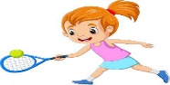
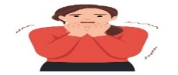

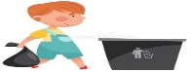

3. DO AS SHOWN BETWEEN BRACKETS
1.5

1– It - a terrible – game – is . ( rearrange ) ………………………………………………………………
mommy | granny | daddy | ( choose the informal word ) 2- She is my mom
4. CHOOSE
1

are | do | does | 1- How often ____ you see your cousin?
watches | watch | watching | 2- He is ______ TV right now .

3
4. CHOOSE
dad - drum - trash can

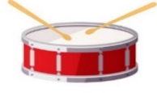 | 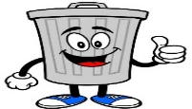 | 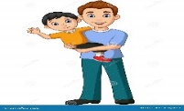


2

Choose the correct letter: ( k - p - m - n ) )

 |  |  | 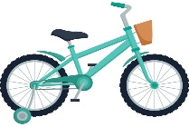
grand_a | kitte_ | Ca_era | Bi_e

___________________________________________________________________________________________________________________________________________________________________________________________________________________________________
Controlled writing

4

Good luck T.



Kingdom of Saudi Arabia
Ministry of Education
……..Education Directorate
………………… School
English Language
elementary Grade 4th
period Exam
…………….\20
الاسم: الصف:

……\ 4 marks

General questions

A.Answer the questions
Yes, I can |  | Can you sweep the floor? | 1
No, she is helpful. |  | What time do you get up for school? | 2
I never forget to feed it. |  | Is your sister lazy? | 3
I always get up at 6 o'clock. |  | How often do you feed the fish? | 4

Controlled Writing
……\ 1 marks
A-reorder.
1-computer \ that \ Whose\ is \ ?

a-Whose computer is that? b-computer whose is that?

……\ 4 marks

Reading short sentence
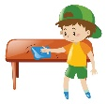 | 1- Saleh usually clears the table ( )
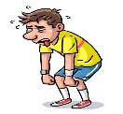 | 2- He isn’t comfortable with other people. He is shy ( )
A-Put ( ✔ ) or ( X )
B. Choose the correct answer
c-cuts | b-drives | a-feeds | 1- My brother ………….the grass.
c-parents | b-grandparents | a-grandchildren | 2- Your mom and dad are your………

……\ 4 marks

Grammar
A-Choose the correct answer.
c-lived | b-lives | a-live | 1- Do you ………. in Jeddah?
c-Is | b-Am | a-Are | 2-………. they getting up now?
c- playing | b- play | a- plays | 3- I sometimes….. football after the school.
c-doing | b-does | a-do | 4- How often ……. she walk in the park?

Vocabulary

A.Choose the correct word under each picture
……\ 5 marks

 |  |  | 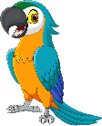  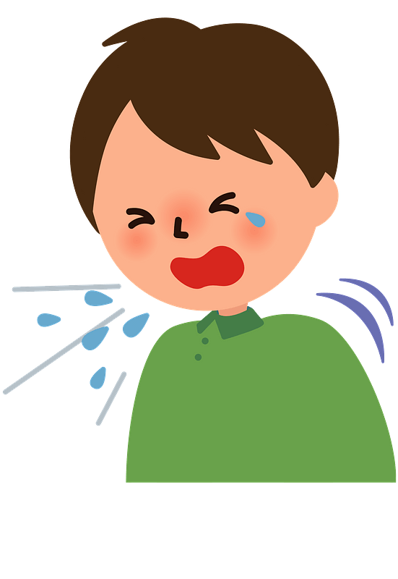 | 
kitten | mother | Comic book | flu | leaves
parrot | grandpa | Trash can | ballon | bus
……\ 2 marks

Orthography
A. Fill in the missing letters

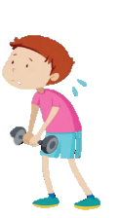
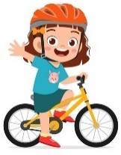


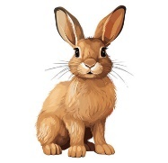

2-Photo…rapher
( g – w - f )
1-bucke…
( t – c - k )
4- Wea…..
( k – v – m )

( s – t - o)
3- grand…arents
( j – p – h )

( s – t - o)


Your teacher:

Your teacher …..:…………………………….



First Period Exam – Top Goal1

مدرسة :
الاسم | الفصل | شفهي | تحريري | المجموع
 | / | 10 / | 10 / | 20 /
Choose the correct answer:
/ 1
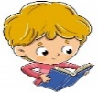
1– What school subject is more difficult at school?

A. I think math. B. I am surprised.
1– What are you doing?

A. I am reading. B. I am eating .
____________________________________________________________________________________________________
/ 1.5
Choose or :
She is afraid. | Take out the trash | She is playing a soccer.
 | 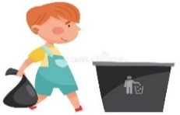 | 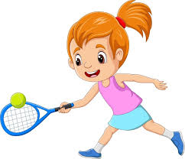
___________________________________________________________________________________________
/ 1.5
1- a terrible – It – game – is ( Rearrange) ………………………………………………………………………………………
grandparents | parents | uncle | 2 - My mom and dad are my ______. (choose )
Do as shown between brackets :
Choose the correct word:
/ 1.5
are | do | does | 1- How often ____ you see your cousin?
were | was | is | 2- We ____ happy .
watches | watch | watching | 3- He is ______ TV right now .

Choose the correct word:
/ 3

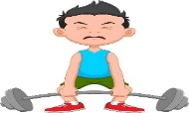 | 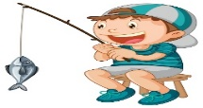 | 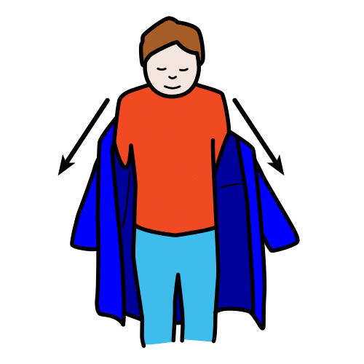 | 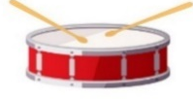 | 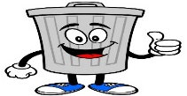 | 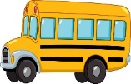  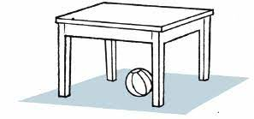
Strong | Cycling | Get dressed | Drum | Trash can | Bus
weak | Fishing | Get undressed | Guitar | Leaves | Poster
Choose the correct letter to fill in the blank:
/ 1.5
 |  | 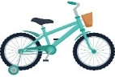
Ca_era | grand_a | Bi_e
n | p | f
m | m | k

Good luck T.
Controlled writing

4


Kingdom of Saudi Arabia 4th Elementary Grade
Ministry of Education First Term

20
3rd Elementary School . . Mid-Term Exam 1447 AH
Name: ………………………………………………………….………………. Class : …………..
- General Questions:
- Choose the correct answer:
1- Which food do you think smells terrible?
a- My little brother |  |  |  |  |  | b- I think fish
2- What school subject is more difficult?
a- Math |  |  |  |  |  | b- I go to school by bus
3- How many brothers do you have?
a- spiders |  |  |  |  |  | b- I have 3 brothers
4- Whose dress is this?
a- It is mine |  |  |  |  |  | b- I always see them
- Controlled Writing:
- Rearrange the words to form a sentence:
early |  |  | My sister |  |  | sleeps |  |  |  | always
- Reading short sentence:
- Read the sentences then match them with the correct pictures:
 |  |  | 
a-_They are different.  b-_They are same. | a-_He is shy.  b-_He is naughty. | a-_I never read book  b-_I always read book | a-_I often go cycling  b-_I often go fishing

- Grammar:
- Choose the correct answer:
- He ……… absent in the class yesterday.
- was |  |  |  | - were |  |  |  |  | - are
- It is my pen. It is …………
- yours |  |  |  | - mine |  |  |  |  | - hers
- Huda is ………… than Rana.
- tall |  |  |  | - taller |  |  |  |  | - tallest
- Vocabulary:
- Choose the correct answer:
 |  |  |  |  |  |  |  |  |  |  | 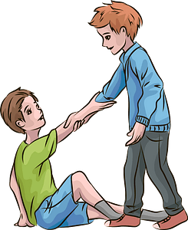
- brilliant  - exciting |  | - pizza  - fish |  |  |  |  | - afraid  - surprised |  |  |  | - dangerous  - helpful
- Orthography:
- Choose the correct missing letters:
  d__ums |  |   k__tten |  |  |  |  | 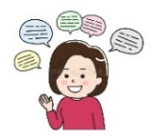  chatt__ |  |  |  | 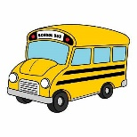  b__s
e | r | i |  |  | m |  | o | y |  |  | e | u

BEST OF LUCK
Ms. Tahani Al-Ghamdi

Kingdom of Saudi Arabia
Ministry of Education
……..Education Directorate
………………… School
English Language
elementary Grade 4th
period Exam
…………….\20
Student's Name : class:

……\ 4 marks

General questions

A.Answer the questions
I never forget to feed it. |  | What are you afraid of? | 1
It's mine. |  | What school subject is more difficult at school? | 2
I think math is more difficult. |  | Whose dress was it?? | 3
I'm afraid of spiders. |  | How often do you feed the fish? | 4

Controlled Writing
……\ 1 marks
A-reorder.
1-computer \ that \ Whose\ is \ ?
………………………………………………………………………………………………………

……\ 4 marks

Reading short sentence
 | 1- He is playing on the guitar ( )
 | 2- My little brother is kind . He always feeds dogs. ( )
A-Put ( ✔ ) or ( X )
B. Choose the correct answer
Math | naughty | School | 1-My little brother is very …………..
helpful | chatty | lazy | 2- Noura likes to talk a lot. She is very…………

……\ 4 marks

Grammar
A-Choose the correct answer.
1-I’m( do – did – doing) my homework.
2-The chocolate cake ( was – were – am )delicious.
3-Omar usually( go – goes – going ) fishing on the weekend.
4-How ( old – much – often) does your sister go cycling?

Vocabulary
……\ 5 marks
A.write the correct word under each picture
( strong - drums - bus - cat - grandpa)
)

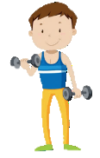 |  |  |  | 
Orthography
……\ 2 marks

A. Fill in the missing letters



1-Ca…..era
( m – j - y )
4- ….allon
( k – b - s )

3- …ycling
( l - c - x)
2- rab…it
( b – j - s )

Your teacher:

Your teacher …..:…………………………….

