"The only thing standing between you and outrageous success is continuous progress."
B. Correct the mistake (1.5 Marks) – (Each = 0.5 mark)
1. She eat breakfast right now.
________________________________
2. They have been watch TV since 7 o’clock.
________________________________
3. While I cooked dinner, my sister was setting the table.
________________________________

III. READING (3 Marks)
Read the passage then answer True (T) or False (F):
Tom enjoys playing sports after school. His favorite sport is basketball, and he plays with his friends every weekend. Sometimes they also play soccer when the basketball court is busy. Tom always brings water and snacks for everyone.
1. ( ) Tom plays basketball every weekend.
2. ( ) Tom never plays soccer.
3. ( ) Tom likes to play sports with his friends.
4. ( ) Tom is already on the school team.
5. ( ) Tom brings snacks when he plays sports.

اختبار الفترة الأولى
MEGA GOAL 1

I. VOCABULARY (3 Marks)
A. Choose the correct answer (1.5 Marks) – (Each question = 0.5 mark)
1. Heavy __________ in big cities often causes delays.
a) economy b) pollution c) traffic d) disease
2. Governments work together to fight against __________ and keep people safe.
a) teamwork b) terrorism c) honesty d) economy
3. Good __________ helps people work well together.
a) teamwork b) honesty c) pollution d) economy
B. Match the words with their meanings (1.5 Marks) – (Each = 0.5 mark)
Word | Meaning
1. To launch | ( ) a. To produce a change
2. To affect | ( ) b. To set up or start
3. To take for granted | ( ) c. To accept as part of life

II. GRAMMAR (4 Marks)
A. Choose the correct answer (2.5 Marks) – (Each question = 0.5 mark)
1. We were ______ TV when it rained.
a) watch b) watching c) watched
2. She ______ two emails today.
a) has written b) is writing c) wrote
3. They ______ in three different cities.
a) have lived b) live c) lived
4. The movie starts ______ eight o’clock.
a) at b) on c) in
5. He ______ his grandmother yesterday.
a) visited b) visits c) is visiting

وزارة التعليم
إدارة التعليم في جازان
مدرسة

[unit 1-2 ] First monthly exam
A
Name:……………………………………………………..
Read the passage and answer the questions below:
Tim loves to go with his mother when she goes grocery shopping. His favorite store is right next door to the grocery store. It is Billows Book Store. Tim goes straight to the bookstore when they get to the grocery store. Mom buys groceries. Tim’s favorite section is the sports section for children. They have all kinds of books about sports. There are magazines that tell everything about sport. Tim likes sports and he spends a lot of time looking at the books and magazines in this section. He likes the area with children’s books, too. Tim always waits in the bookstore for Mom to come and get him. He chooses one book, or a magazine and Mom buys it for him. It is a nice way to spend a Saturday afternoon.

1/ When does Tim go to the bookstore?

a) Friday morning b) Sunday morning c) Saturday afternoon d) Monday

2/ Why does Tim like to go grocery shopping with his mom?

a) goes to ice cream shop b) goes to bookstore c) likes to buy clothes

Grammar
3/ did they ……………………………… at the same school?
a) study b) studied c) studies d) studying
4/ I………………………..my essay last night .
a) write b) writes c) writing d) wrote
5/ I was doing my homework when the door……………..
a) open b) opened c) opens d) opening
6/ I have been teaching ………….2004
a) for b) since c) ago d) just
7/ He is interested in ……………………video games.
a) play b) played c) playing d) played
8/ She has …………………three meals .
a) cooked b) cook c) cooks d) cooking
9/ the person ……………….you met, was my father.
a) which b) when c) where d) who
10/ I………………..to gym every day.
a) went b) go c) goes d) going

choose
[ a) poverty b) friendly c) resume d) flavor]
11 /the meeting was very……………………..
12/ the only ice cream……………….. that he eats is Vanilla.
13/ ……………….drove him to steel

Match
A B
14/ fit in a) to accept as part of life
15/ hub b) very bored
16/ bored to death c) to set up, start
17/ To take for granted d) be part of
e) center
Match these words with pictures



[ a) poverty b) disease c) clay d) team work
18 19 20

Optional question
What does " Vision " mean ?
…………………………………………………………………………………………………………………………………………..
……………………………………………………………………………………………………………………………………….

Best wishes 😊
T. Areej AL-Msned

First monthly exam
B
Name:………………………………………………………..
Read the passage and answer the questions below
Tim loves to go with his mother when she goes grocery shopping. His favorite store is right next door to the grocery store. It is Billows Book Store. Tim goes straight to the bookstore when they get to the grocery store. Mom buys groceries. Tim’s favorite section is the sports section for children. They have all kinds of books about sports. There are magazines that tell everything about sport. Tim likes sports and he spends a lot of time looking at the books and magazines in this section. He likes the area with children’s books, too. Tim always waits in the bookstore for Mom to come and get him. He chooses one book or a magazine and Mom buy it for him. It is a nice way to spend a Saturday afternoon.

1 /What does Tim like to read about?

a) cars b) animals c) sports d) bikes
2/ What does Tim's mother do when she comes to get Tim?

a) gives him food b) buys a book or magazine c) buys an ice cream

Grammar
3/ does she ……………………………… football?
a) plays b) played c) play d) playing
4/ I………………………..my old work two years ago.
a) leave b) leaves c) leaving d) left
5/ I was sleeping when my mom ……………..
a) call b) called c) calls d) calling
6/ she has been reading ………….two hours.
a) since b) for c) ago d) just
7/ He is good at ……………………computers.
a) use b) used c) using d) uses
8/ I have …………………many kind of cake.
a) baked b) bake c) bakes d) baking
9/ the dress ……………….you buy is amazing
a) who b) when c) where d) which
10/ she………………..her parents every week.
a) visit b) visits c) visited d) visiting

choose
a) security b) traffic c) resume d) unpaid ]
11 /He had a……………………accident.
12/ the city is trying to collect …………………..taxis.
13/ He is a ……………….guard at the airport.

Match
A B
14/ day after day, day in day out a) center
15/ to established b) changing completly
16/ transforming c) very board
17/ hub d) following the same pattern
e) to set up, start
Match these words with pictures
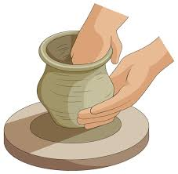

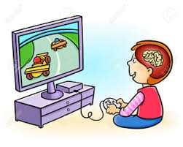
[ a) pollution b) clay c) disease d) interactive games
18 19 20

Optional question
What does " visionary " mean ?
…………………………………………………………………………………………………………………………………………..
……………………………………………………………………………………………………………………………………….

Best wishes 😊
T. Areej AL-Msned

[unit 1-2 ] First monthly exam
A
Name:……………………………………………………..
Read the passage and answer the questions below:
Tim loves to go with his mother when she goes grocery shopping. His favorite store is right next door to the grocery store. It is Billows Book Store. Tim goes straight to the bookstore when they get to the grocery store. Mom buys groceries. Tim’s favorite section is the sports section for children. They have all kinds of books about sports. There are magazines that tell everything about sport. Tim likes sports and he spends a lot of time looking at the books and magazines in this section. He likes the area with children’s books, too. Tim always waits in the bookstore for Mom to come and get him. He chooses one book, or a magazine and Mom buys it for him. It is a nice way to spend a Saturday afternoon.

1/ When does Tim go to the bookstore?

a) Friday morning b) Sunday morning c) Saturday afternoon d) Monday

2/ Why does Tim like to go grocery shopping with his mom?

a) goes to ice cream shop b) goes to bookstore c) likes to buy clothes

Grammar
3/ Do you ……………………………… at the same school?
a) work b) worked c) works d) working
4/ I………………………..early last night .
a) sleep b) sleeps c) sleeping d) slept
5/ I was cooking when my father……………..
a) arrive b) arrived c) arrives d) arriving
6/ I have been working ………….6:00 a.m.
a) for b) since c) ago d) just
7/ He is interested in ……………………documentary .
a) watch b) watched c) watching d) watched
8/ She has …………………three books.
a) studied b) study c) studies d) studying
9/ the women ……………….you met, was my sister.
a) which b) when c) where d) who
10/ I………………..a book every weekend.
a) is read b) read c) reads d) reading

choose
[ a) disease b) creative c) resume d) flavor]
11 /she is very………………….and always coming up with new ideas.
12/ the only ice cream……………….. that he eats is Vanilla.
13/ She's suffering from a serious…………………………..

Match
A B
14/ fit in a) to accept as part of life
15/ hub b) very bored
16/ bored to death c) to set up, start
17/ To take for granted d) be part of
e) center
Match these words with pictures
[ a) poverty b) disease c) clay d) team work
18 19 20

Optional question
What does " what will be, will be " mean ?
…………………………………………………………………………………………………………………………………………..
……………………………………………………………………………………………………………………………………….

Best wishes 😊
T. Areej AL-Msned

First monthly exam
B
Name:………………………………………………………..
Read the passage and answer the questions below
Tim loves to go with his mother when she goes grocery shopping. His favorite store is right next door to the grocery store. It is Billows Book Store. Tim goes straight to the bookstore when they get to the grocery store. Mom buys groceries. Tim’s favorite section is the sports section for children. They have all kinds of books about sports. There are magazines that tell everything about sport. Tim likes sports and he spends a lot of time looking at the books and magazines in this section. He likes the area with children’s books, too. Tim always waits in the bookstore for Mom to come and get him. He chooses one book or a magazine and Mom buy it for him. It is a nice way to spend a Saturday afternoon.

1 /What does Tim like to read about?

a) cars b) animals c) sports d) bikes
2/ What does Tim's mother do when she comes to get Tim?

a) gives him food b) buys a book or magazine c) buys an ice cream

Grammar
3/ did she ……………………………… football?
a) plays b) played c) play d) playing
4/ I………………………..my old work two years ago.
a) leave b) leaves c) leaving d) left
5/ I was sleeping when my mom ……………..
a) call b) called c) calls d) calling
6/ she has been reading ………….two hours.
a) since b) for c) ago d) just
7/ He is good at ……………………computers.
a) use b) used c) using d) uses
8/ I have …………………many kind of cake.
a) baked b) bake c) bakes d) baking
9/ the dress ……………….you buy is amazing
a) who b) when c) where d) which
10/ she………………..her parents every week.
a) visit b) visits c) visited d) visiting

choose
a) security b) traffic c) resume d) organized ]
11 /He had a……………………accident.
12always keep your workplace………………………….
13/ He is a ……………….guard at the airport.

Match
A B
14/ day after day, day in day out a) center
15/ to established b) changing completely
16/ transforming c) very board
17/ hub d) following the same pattern
e) to set up, start
Match these words with pictures
[ a) pollution b) clay c) disease d) interactive games
18 19 20

Optional question
What does " science fiction " mean ?
…………………………………………………………………………………………………………………………………………..
……………………………………………………………………………………………………………………………………….

Best wishes 😊
T. Areej AL-Msned



Unit 1-2 Exam Mega 1.1
Name:…………………………………. Class:………
1-Comprehension
In 1990, Tim Berners-Lee and Robert Dailliau introduced the “Worldwide Web”. About 26 years later, 16 million people were online, and email was taking over. Today there are more than four and a half billion users.
E-mail, instant messaging, and video calls connect people across the globe. Social networks allow people to communicate with a large number of friends and information is accessible to everyone online. All you need to do is ‘Google’ a few key words and you get numerous sites and documents.
Read the passage then answer the questions:
1- How many Internet users are there today?
……………………………………………………………………………………………………………..….
2- What do you need to do to get numerous sites and documents?
…………………………………………………………………………………………………………………
3- Does social networks allow people to communicate with each other?
…………………………………………………………………………………………………..…………….
4- Information isn't accessible to everyone online. or ×
-------------------------------------------------------------------------------------------------------------------

2-Vocabulary
A- Match the word with its meaning:
1- vibrant ( ) a- center
2- established ( ) b- job .
3- career ( ) c- set up - start
4- hub ( ) d- active & strong

Qb- Choose the correct answers ;
( traffic - sculptor - economy - microscope )
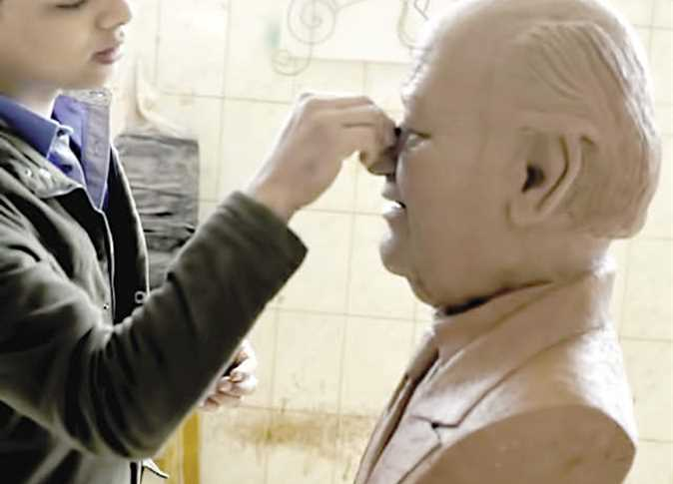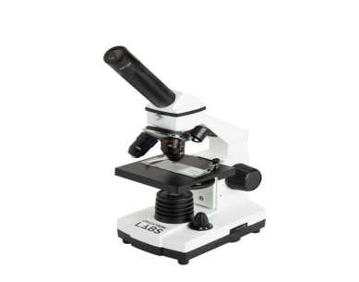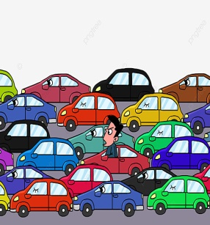
………………………………………………………………………………………………………………….
3-Grammar
A- Choose:
1-It is ( rain – rains - rained – raining ) right now
2-This is the boy ( who - which – where – when ) had an accident .
3-He is interested ( at - in – on – of ) reading novels .
4- ( How long – How much – How many ) lessons has she explained ?
5-She ( clean - cleans – cleaned - cleaning ) her house yesterday .
6-Ahmed has ( eat - eats - eaten ) three burger .
4--Writing
- Rewrite using capitals:

- jack decided to fly to new york next monday.
……………………………………………………………………………….
2-my brother has never been to dubai .
……………………………………………………………………………………
3-riyadh is the capital of Saudi arabia .
…………………………………………………………………………………….

Best Wishes,

Kingdom of Saudi Arabia
Minster of education in Arass
6th secondary school

Midtearm exam for 1st secondary school
Name: ………………………………………….
: 1)- Write about
A-Adventure to Malizya
Statue of Morgan – Sightseeing - Exciting - Adventurous))
Adventure to ……………………………………..
……………………………………………………………………………………………………………………………
……………………………………………………………………………………………………………………………
……………………………………………………………………………………………………………………………
……………………………………………………………………………………………………………………………
……………………………………………………………………………………………………………………………
……………………………………………………………………………………………………………………………
……………………………………………………………………………………………………………………………
B- My dream job:
………………………………………………………………………………………………………………………………………………………………………………………………………………………………………………………………………………………………………………………………………………………………………………………………………………………………………………………………………………………………………………………………………………………………………………………………
2)- Comprehension:
*Read the paragraph then answer the questions below:
Ali is a doctor at Abha Private Hospital . He has a bachelor in medicine and surgery . He is organized, friendly and reliable . He has worked at 3 hospitals. Ali speaks English fluently and has computer skills.
*Answer (T or F):
1- Ali is a teacher. ( )
2- Ali works in school. ( )
3- Ali has a bachelor in Math. ( )
4- Ali speaks French fluently. ( )

3)- Grammer:
A)- Choose the correct form in brackets
1-Ali ( wake up – woke up - wakes up ) early every morning .
2- He doesn't ( brush – brushes – brushing ) his teeth .
3- It is ( rain – rains – raining ) right now .
4- They have ( played – plays - playing ) tennis three times.
5- He works at the hospital (on – in – at ) Sunday.
6- ( How long – How much – How many – How often ) lessons has she explained ? .
B)-Do as shown between brackets :
1- This is the boy ……………… won yesterday. (Complete with who or which )
2- It was raining .we were playing football . ( join with while )
…………………………………………………………………………………………..
3- He drinks milk every morning. ( Change into negative ) …………………………………………………………………………………………………
4- Who………………………………… ? (Complete the question)
She is my old sister.
4)- Vocabulary
A- circle the odd word:
1- journalist – interviewer – designer – honest .
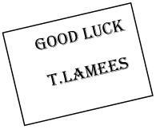
2- confident – nurse - intelligent– organized.
B- Match the word with the meaning:
1- career ( ) set up - start.
2- establish ( ) work – job.
3- hub ( ) social.
4- interpersonal ( ) center .

C- Underline the correct word for each picture

(unemployment – host) ( disaster – traffic ) ( security – economy ) ( global warming –disease)

