
Kingdom of Saudi Arabia
Ministry of Education
………………… School
English Language
Intermediate Grade 2nd
1st period Exam
……….\20


Student's Name : class:

……\ 5 marks
1-Read the following passage and answer the questions below:
Ali wanted to try a new sport. One day, he joined a karate class in his town. At first, he was afraid because karate looked difficult. The teacher gave him a white uniform and white belt. Ali started to learn how to kick, block, and punch. With practice, he became stronger and more confident. His teacher told him that karate is not just about fighting, but also about respect and self-control. After many months, Ali worked hard and earned a yellow belt. Karate helped Ali become healthy, brave, and focused.
c- tennis | b- basketball | a- Karate | 1- What sport did Ali join?
c- Books and pens | b- Short and cap | a-uniform and belt | 2- The teacher gave him…………………
c-sad | b-afraid | a-hungry | 3-How did Ali feel at first in the karate class?
c-Yellow | b-Blue | a-Green | 4- Which belt did Ali earn ?
c-brave | b-tired | a-lazy | 5- Karate helped Ali become…….
A.Choose the correct answer.
……\ 5 marks
2-Choose the correct answer.

c-am | b-is | a-are | 1- Riyadh………..in Saudi Arabia.
c- sleeps | b- sleeping | a- sleep | 2- Are you …………..?
c-What | b-How | a-Where | 3-………….old are you?
c- making | b- makes | a- make | 4- Sara is …………. a cake.
c-opened | b-open | a-opens | 5-……….the book please.
c-are | b-is | a-am | 6- Aisha and Fadwa ………. at the mall.
c- smelling | b- smells | a- smell | 7- The pizza ………….. good.
c- am | b- are | a-is | 8- Who …………….your teacher?
c- eat | b- eats | a- eating | 9- Don't ………… junk food.
c-like | b-likes | a-liking | 10- I ……………..martial arts films.

3-Do as shown between brackets.
……\ 2 marks
a-( make a Yes or No question)
They are working now.
……………………………………………………………………………..…..?
b-( Reorder)
are\ Where \from \you\?..............................................................................

……\ 4 marks
4- write the correct word under each picture ( karate - volcano - elevator - credit card )
)

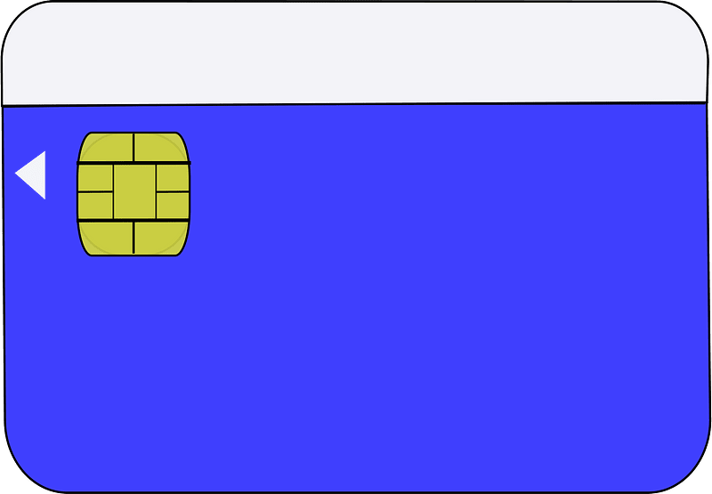
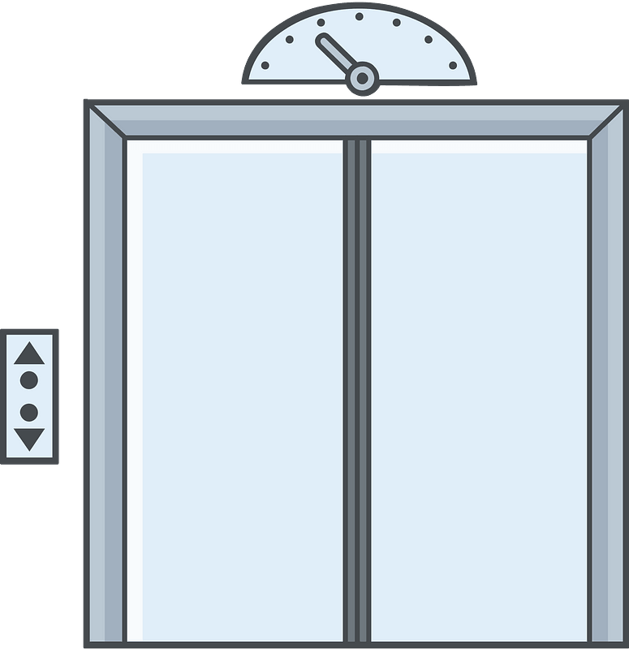
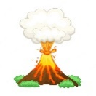
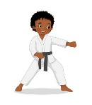

………………………
………………………
………………………
………………………

……\ 2 marks
5- Choose the correct answer.
1-(script -soup - sofa ) is the words of a movie, play, or speech
2- I'd like to make a table (business – reservation – mall ) for two people for nine o'clock.

6.Choose the missing letter.
1- I had just returned from the Cannes Film Fe….tival. ( q - s - w )
2- …ideos is becoming popular tool for e-learning. ( V- H – T)
3- The camera o…erator is holding the camera.( n – j – p )
4- During his summer ……acation, he visited Dubai. ( d - a - v )

……\ 2 marks

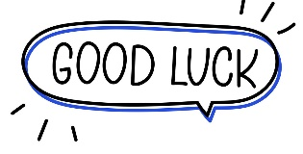

Your teacher:


Kingdom of Saudi Arabia Name: ……………………………
Ministry of education Class: 2nd Intermediate Grade
10 /
…….. Intermediate School First Exam - 1448 First Term
- Grammar:
- Choose:
- I (am – is – are) a smart student.
- This is the boy (who – which – when) had an accident
- Messi (play – plays – is playing) football now.
- The actors are ready to perform (over – in front of – under) the camera.

- Do as shown between brackets:
- Rasha bakes a cake. (Change into negative)
…………………………………………………………
- I (seeing) a bird in the tree. (Correct the verb)
…………………………………………………………

- Vocabulary:
- Write the words under the pictures:
salary – cameraman – key card – hotel – run away


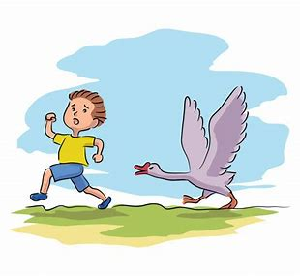


_____________ _______________ ________________ ______________

- Fill in the blank with the correct words in the box:
feed – festival – engineer

1- Fahad wants to be an ……………… in the future.
2- The baby is too young to …………………. itself.

- Match:
- All by myself a- an expression used when you give something to someone
- Here you are b-see you later
. c- with no one else’s help

- Orthography:
- Fill in the missing letters:
- I will call the hotel and make a reser__ation.
- She like to wear e__otic clothes.
- Have you ever watched this fi__m?
- The scr__pt is well-written.

Good Luck
Ms. Tahani Al-Ghamdi

Kingdom of Saudi Arabia
Ministry of Education
………… Education Directorate............
…………..……………….. Intermediate School

Total
المجموع | تحريري | شفهي
20 | 10 | 10

First Period Exam
Second Intermediate Grade

Name ………………………………… Class ………………………………
__________________________________________________________________________________________
/ 2
Comprehension

Read the following then answer the questions:

My family and I always go to the beach in the summer. We eat sandwiches and ice cream. We will drink orange juice. My brother likes to swim. My sister likes to likes to play with dad. We all have a good time .
A- Put (√ ) for true or ( ᵡ ) for false :

( ) | 1. We go to the beach in winter .
( ) | 2. My brother likes to play football.

B- Choose the right answer:

ice cream | apple | bread | meat | 1-Thy eat sandwiches and______.
brother | friend | dad | mom | 2-my sister likes to play with _____.
_________________________________________________________________
/ 2.5
Grammar

Choose the right answer:

1- We ___________ here for the festival.
A. is B. am C. are D. do
2 - ______ are you doing? Fine, thanks
A. Where B. How C. When D. which
3 - I am ______ a book now?
A. reading B. reads C. read D. write
4 - He is _______ in a hospital now.
A. work B. working C. works D. worked
5 - The waiter _______is serving the customers is friendly.
A. which B. who C. when D. how

/ 2
Vocabulary

A- Choose the best answer to fill in the blank:
1. _________ are good places for meeting people.
D. Playground | C. Room | B. Schools | A. Hotels
.2. Good night. ___________ tomorrow
D. Good afternoon | C. See you | B. Good bye | A. Good morning
3- Are you here for the conference? No, I’m here on ________ with my family.
D. playing | C. study | B. vacation | A. hotel
4- Half of the people in Saudi Arabia are under the _____ of 25.
D. strong | C. tall | B. age | A. old
B- Put the right word under its picture:
/ 2.5
 | 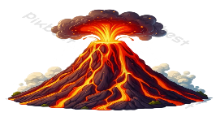 |  |  | 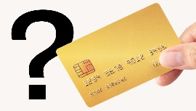

Credit card - engineer - cameraman - reception desk - volcano

_______________________________________________________________________________
/ 1
Orthography

Choose the correct letter:
k | h | d | 1. I’d like to intro_uce you to Joe.
b | m | t | 2. The soup s_ells good .

Good luck T.

Name :…………………………………………………………………… Class:…….……….
Super Goal 2 - Test unit 1 & 2

Reading
2 Marks
- Read the text and answer the questions. Write T or F at the end of each question/statement.
I like to go to the sports center. I go there every weekend. At the sports center, you can do many things. For example, you can play golf or tennis. There is a pool, so you can also swim or relax by the pool. There is a beach next to the sports center. You can swim, water-ski, or windsurf in the ocean. You can also sail on windy days. There aren’t any fish near the beach, so you can’t snorkel. When I go to the sports center, I like to play volleyball on the beach. I also like to jog on the beach. I can’t swim well, so I don’t like to water-ski or windsurf.
- At the sports center, you can do many things. ( )
- You can swim in the pool or in the ocean. ( )
- People can windsurf in the pool. ( )
- You can’t use a boat in the ocean. ( )
Grammar
5 Marks
- Choose the best answer to fill in the blank in each question.
- Who _____ that girl?
a. am b. is c. are d. i
- John: _____ your friend? - Adnan: He is in the restaurant.
a. How’s b. What’s c. When’s d. Where’s
- It _____ a beautiful day today.
a. is b. are c. not d. am
- _____ in that new TV film?
a. He acting b. He is acting c. Is acting d. Is he acting
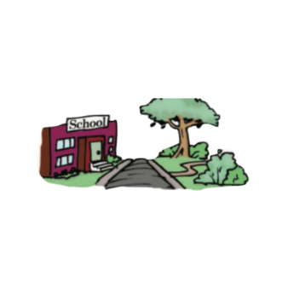
- What is he eating ? - he's ________ an apple .
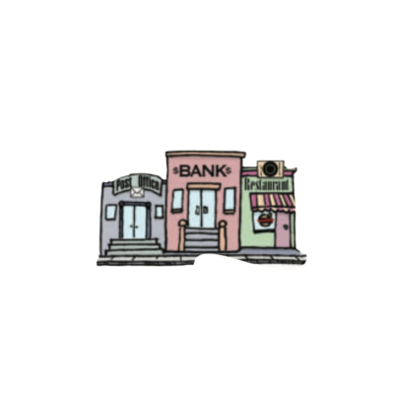
a. eat b. is eat c. eating d. ate
1.5 Marks
- Use ( across from – next to – between )
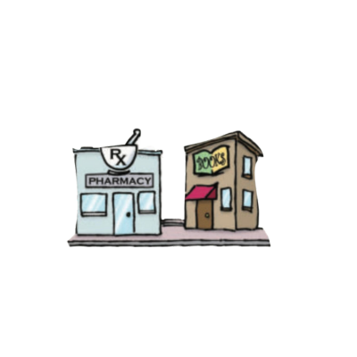
- The park is ____________________ the school .
- The bank is ______________ the post office and the restaurant .
- The pharmacy is ______________ the bookstore .

- Write the imperative sentence.
1.5 Marks
- Will you clean up this mess? ________________________________________
- Why aren’t you eating your vegetables? _______________________________
- You can’t take photographs. _________________________________________

Vocabulary
- Choose the best answer to fill in the blank in each question.
5 Marks
- Thank you !
a. You’re welcome. b. He’s from Muscat. c. That’s all right. d. Hi
- What is your country ?
a. Fine thank you b. I'm 13 years old c. Nice to meet you d. I'm from Saudi Arabia
- Many young people traveling around the world are ________ .
a. old people b. backpackers c. teachers d. business men
- What is the cook doing ? - He’s _______ soup .
a. making b. breaking c. writing d. talking
- ________ sometimes use webcams in the classroom.
a. Students b. Teachers c. Farmers d. business men

- Write the correct word under the picture.
3 Marks
coffee shop – Webcam – Turn Right





…………………………………………….

…………………………………………….
…………………………………………….

- Choose the correct letter.
2 Marks
- See you tomorr…..w. ( o – y – r )
- I don't he….r anything. ( t – a – r )


English Language
Intermediate Grade 2nd
period Exam
Kingdom of Saudi Arabia
Ministry of Education
………..Education Directorate
………………… Intermediate School

Student's Name : class:

Reading comprehension ✦
……\ 5 marks
1-Read the following passage and answer the questions below:
Sami is the editor of The Daily news. All the reporters and photographers at the newspaper like Sami a lot. He’s a great boss and they enjoy working with him. He lives in Jeddah . He works very hard and gets home after eight in the evening. He’s usually very tired . His wife is a part-time chef so she cooks lovely food for them. Sami doesn’t have much free time but, when he does he loves watching TV and surfing the Net. His dream is to take karate lessons and become active in the future.

1- Sami is the ……….. of The Daily news.
c- doctor | b- teacher | a- editor
2- He’s a ……………. boss.
c- old | b- bad | a- great
3- Sami lives in …………….. .
c- Jeddah | b- Abha | a- Riyadh
4- His wife is a part-time …………….
c- chef | b-nurse | a-engineer
5- His dream is to take ………. lessons
c- French | b- karate | a- cook

Grammar ✦
A. Choose the correct answer.
1- (open – opening – opened ) the book please.
2-Riyadh(is – are – am )in Saudi Arabia.
3- I ( isn't – aren't – am not ) doctor.
4- Are you ( sleep – sleeping – sleeps )?
5-Who ( is – are – am ) your teacher?
6- Sara is ( make – makes – making ) a cake.
7- Don't ( eat – eats – eating ) junk food.
8-( How – what – where ) old are you?

……\ 4 marks



B. Do as shown between brackets.
1-( Correct)
a- Dubai aren't in Egypt. …………….
b- Closing the window please.. ………………
2-(Give a short answer)
a- is he a doctor ?
- No,………………………………………………………………
3-(make a Yes or No question)
a-They are working now.
…………………………………………………………..……….?

……\ 4 marks

✦ Vocabulary
……\ 5 marks
A-choose the correct answer.
1- ( hostel – supermarket – bank ) is a place where young people can stay cheaply.
2-(script -soup - sofa ) is the words of a movie, play, or speech.
B- Write the correct word under each picture

webcam elevator credit card volcano



…………………………
…………………………
…………………………
…………………………
A. Choose the missing letter.

1- During his summer ……acation, he visited Dubai. ( v - a - d )
2- I had just returned from the Cannes Film Fe….tival. ( q - s - w )
✦ Orthography
Choose the corre

……\ 2 marks

B. Write the missing letter.


1-Ca…..era ( u – m – z )
Your teacher:

2-Fi….h ( s - g - r )

The end of the questions
Good luck
Your teacher ………………………

Kingdom of Saudi Arabia
Ministry of Education
………… Education Directorate............
…………..……………….. Intermediate School

20
Total

Midterm Test units 1 & 2
Second Intermediate Grade

Name ………………………………… Class ………………………………
__________________________________________________________________________________________
/ 4
Comprehension

Read the following then answer the questions:

Last weekend, I went to a new shopping mall that opened last month. The shopping mall is so huge and has five gates. Inside the mall, there are many stores and a place for people to pray. Also, the mall has a food area with more than 5 different restaurants.
A- Put (√ ) for true or ( ᵡ ) for false :

( ) | 1. The shopping mall opened last week.
( ) | 2. The mall has five gates.

B- Choose the right answer:

beautiful | crowded | huge | small | 1-The mall is so ______.
sleep | pray | play | study | 2-Inside the mall there is a place for people to _____.
_________________________________________________________________
/ 5
Grammar

Choose the right answer:

1- We ___________ here for the festival.
A. is B. am C. are D. do
2 - ______ are you doing? Fine, thanks.
A. Where B. How C. When D. which
3 - What are you ______ now?
A. doing B. do C. does D. did
4 - I _______ martial arts films.
A. am liking B. likes C. like D. liking

5 - The apple is _______the boxes .
A. under B. on C. in D. between

/ 4
Vocabulary

A- Choose the best answer to fill in the blank:
1. _________ are good places for meeting people.
D. Playground | C. Room | B. Schools | A. Hotels
.2. Good night. ___________ tomorrow
D. Good afternoon | C. See you | B. Good bye | A. Good morning
3- Are you here for the conference? No, I’m here on ________ with my family.
D. playing | C. study | B. vacation | A. hotel
4- He is _____ ______ in the library.
D. eating a sandwich | C. watching a film | B. reading a book | A. playing a game
B- Put the right word under its picture:
 | 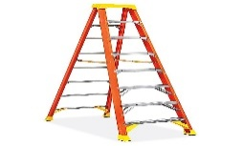 | 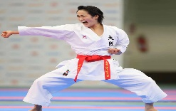 | 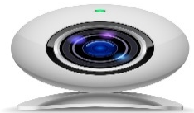 | 
pizza , ladder , webcam , credit card , karate
/ 5

_______________________________________________________________________________
/ 2
Orthography

Choose the correct letter:
k | h | d | 1. I’d like to intro_uce you to Joe.
b | m | t | 2. The soup s_ells good .

Good luck T.

