1
1– What are you going to be when you grow up ?

I. CHOOSE
A. I am going to be an engineer. B. I am going to the market.
2– What is your favorite dish?

A. I am cooking pasta. B. My favorite dish is pizza .
المملكة العربية السعودية |  |  | اسم الطالب/ ......................................
وزارة التعليم
إدارة التعليم بمنطقة |  |  | المادة : انجليزي
مدرسة : |  |  | الزمن :
 |  |  | الصف : فصل ( )
شفهي | تحريري |  |  | المجموع
10 / | 10 / |  |  | 20 /
Top goal2 اختبار الفترة الثانية الفصل الأول - للعام الدراسي 1448– لغة انجليزية –– للصف
اسم الطالب / هـ الفصل /

2. CHOOSE OR
1.5

She bakes a cake.
That is an airport.
That is an engineer .

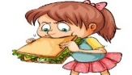


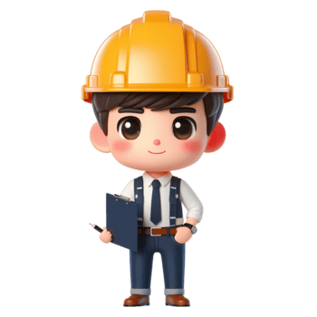

3. DO AS SHOWN BETWEEN BRACKETS
1.5

1- going to /We /be /managers/ are /. / (Rearrange ) ……………………………………………………………………………
Coffee | Water | Chips | 2 - _________ is good for your body . (choose)

4. CHOOSE
1

going to | may | 1- I am ________ to be an artist.
using | use | 2- If I don't have sugar, I _____ honey.

4. CHOOSE
3
pilot - waiter - honey

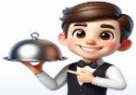 | 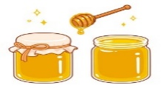 | 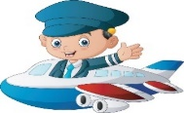


2

Choose the correct letter:

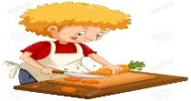 | 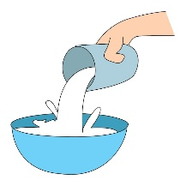 | 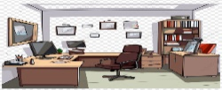 | 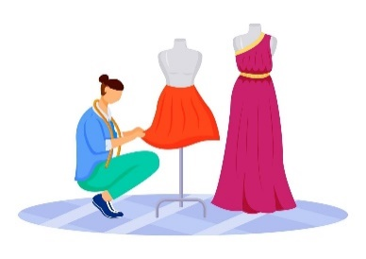
c_t | pou_ | Offi_e | Fashio_ designer
a | t | c | t
u | r | d | n

___________________________________________________________________________________________________________________________________________________________________________________________________________________________________
Controlled writing

4

Good luck T.



Kingdom of Saudi Arabia
Ministry of Education
……..Education Directorate
………………… School
English Language
elementary Grade …..
2nd period Exam
…………….\20
الاسم: الصف:

……\ 4 marks

General questions

A.Answer the questions
receptionist |  | What do you want to do in the future? | 1
I’m going to be photographer. |  | Who works in the reception at a hotel or office? | 2
My favorite food is pizza. |  | Who helps you when your car doesn’t work well? | 3
mechanic |  | What's in your favorite food? | 4

Controlled Writing
……\ 1 marks
A-reorder.
1-planes / . / not / fly / may / He

a-fly may not he planes. b-He may not fly planes.

……\ 4 marks

Reading short sentence
 | 1- He is going to be a singer. His voice is very nice. ( )
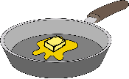 | 2- Melt the butter in a pan. ( )
A-Put ( ✔ ) or ( X )
B. Choose the correct answer
c-stage | b-airport | a-school | 1- The pilot works in the …………
c-butter | b-recipe | a-cookies | 2- It gives instructions to prepare food.

……\ 4 marks

Grammar
A-Choose the correct answer.
c- might | b- may | a- going | 1- I am sure I am ………to be an artist
c-isn't going | b- going | a-may | 2-It’s possible that we.…study acting in the future.
c- isn't | b- doesn't | a- don't | 3- Asma enjoys taking photos,…..…. she?
c-must | b- shouldn't | a- should | 4- You …………cook alone.

Vocabulary
A.Choose the correct word under each picture
……\ 5 marks

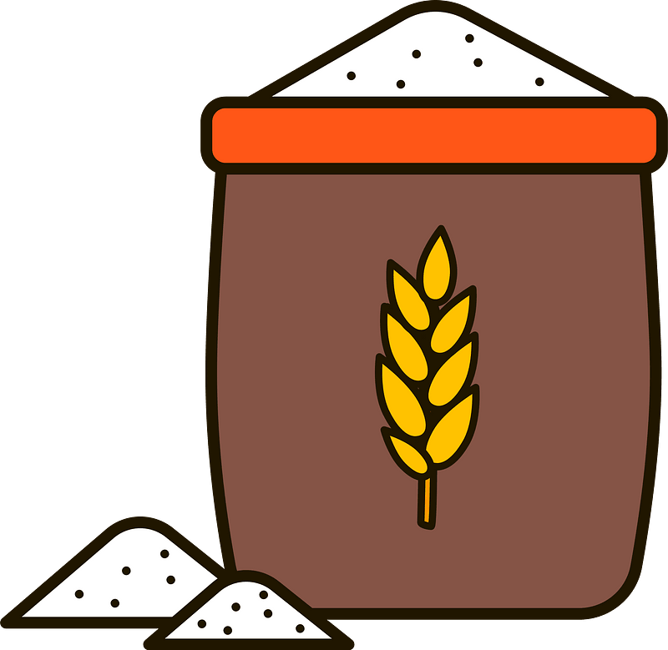 | 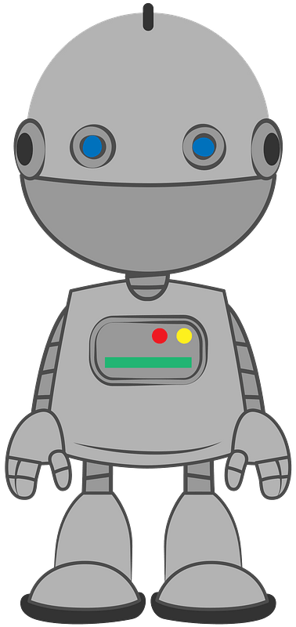 | 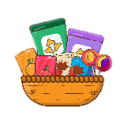 | 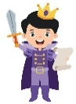  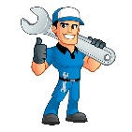
flour | robot | pancake | mechanic | actor
honey | Shelf | snacks | singer | businessman
……\ 2 marks

Orthography
A. Fill in the missing letters
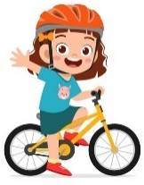

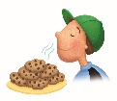
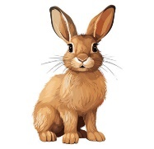
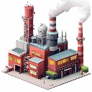
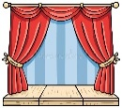
3-d…iver
( r – g - o )
1-s….ell
( y – m - q )
4- fac…ory
( w - d - t)
2-sta…e
( t – f – g )

( s – t - o)

Your teacher:

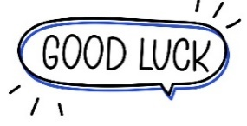
Your teacher …..:…………………………….


Kingdom of Saudi Arabia 5th Elementary Grade
Ministry of Education First Term

10
…………….. Elementary School . . Second Exam - 1448 AH
Name: ………………………………………………………….………………. Class : …………..
- General Questions:
- Choose the correct answer:
1- Who designs houses?
a- Concrete, and steel. |  |  |  |  | b- An architect.
2- Where do you work?
a- I’m going to be a pilot. |  |  |  |  | b- I work in an office.
- Controlled Writing:
- Fill in the blank with the word:
mechanic – driver – key

1- ……………….: You need this to unlock the door to your house.
2- ………………….: This person takes people to different places by buses or cars.
- Reading short sentence:
- Read the sentences then match them with the correct pictures:
 | 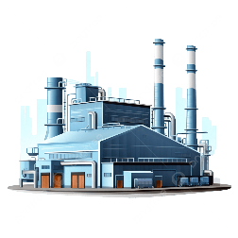 | 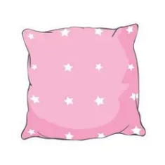 | 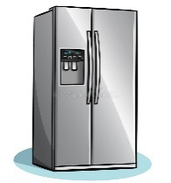
a- He’s an artist.  b- He’s a pharmacist. | a-He works in a factory.  b-He works in a stage. | a-_It is a shelf.  b-_It is a cushion. | a-_It is an oven.  b-_It is a fridge.

IV . Grammar:
- Choose the correct answer:
- She is going to ……….…… to my house after school.
- come |  |  | - comes |  |  |  |  | - came
- I ………….. take you to the hospital right now.
- am |  |  | - am going to |  |  |  |  | - will
- It’s possible that we ……………… study acting in the future.
- may |  |  | - might |  |  |  |  | - are going to
- They can’t be businessmen, ……………?
a- can they |  |  | b- can’t they |  |  |  |  | c- they can
V. Vocabulary:
- Choose the correct answer:
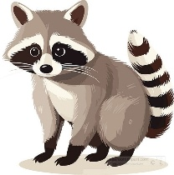 |  | 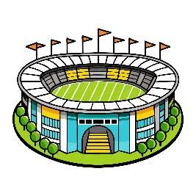 |  |  |  |  |  |  | 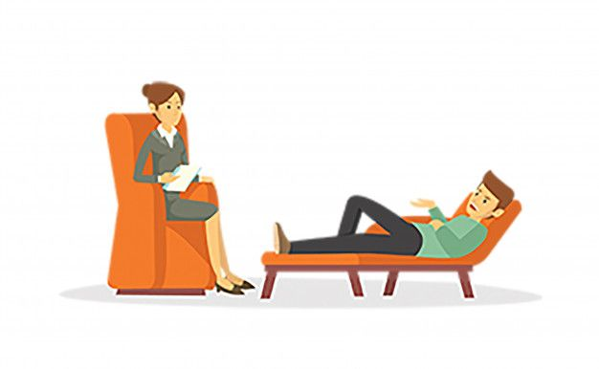
- wolf  - racoon |  | - stadium  - news studio |  |  |  | - singer  - actor |  |  | - therapist  - journalist
VI. Orthography:
- Choose the correct missing letters:
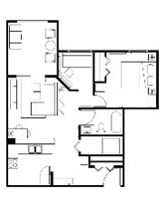  la__out |  | 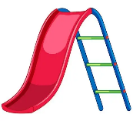  sli__e |  |  |  | 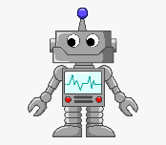  r__bot |  |  | 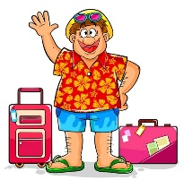  tour__st
i | y | b |  | d |  | o | u |  | i | e

BEST OF LUCK
Ms. Tahani Al-Ghamdi

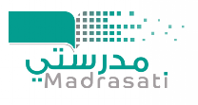
Second Period Exam – Top Goal 2

مدرسة :
الاسم | الفصل | شفهي | تحريري | المجموع
 | / | 10 / | 10 / | 20 /
Choose the correct answer:
/ 1

1– What are you going to be when you grow up ?

A. I am going to be an engineer. B. I am going to the market.
2– What is your favorite dish?

A. I am cooking pasta. B. My favorite dish is pizza .
____________________________________________________________________________________________________
/ 1.5
Choose or :
That is an engineer . | That is an airport. | She bakes a cake.
 |  | 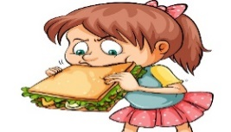
___________________________________________________________________________________________
/ 1.5
1- going to /We /be /managers/ are /. / (Rearrange ) ……………………………………………………………………………
Coffee | Water | Chips | 2 - _________ is good for your body . (choose)
Do as shown between brackets :
Choose the correct word:
/ 1.5
going to | may | 1- I am ________ to be an artist.
Isn't he | Is he | 2- He is going to work here, ________?
turn | turned | 3- You should ________ the oven on .

Choose the correct word:
/ 3

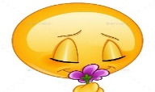 | 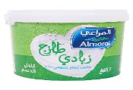 |  |  |  | 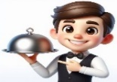  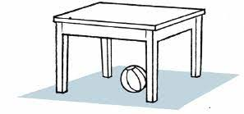
smell | fruit | sugar | stage | pilot | mechanic
taste | yogurt | honey | airport | doctor | waiter
Choose the correct letter to fill in the blank:
/ 1.5
pou_ | Offi_e | Fashio_ designer
t | c | t
r | d | n

Good luck T.
Controlled writing

4



اسم الطالب ……………………………………………………………………….……………………………….……………………الصف……………………………….


Match the questions to the answers:ضع رقم السؤال في مربع الجواب المناسب

1-What are you going to be in the future? My favorite dish is pasta.

2- What’s your favorite dish? I am going to be a robot manager.

Choose the correct answer:ضع دائرة على الإجابة الصحيحة

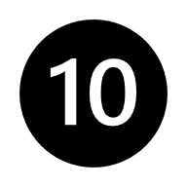
- She doesn’t like TV. She (may – may not ) be an actor.
- He likes news. He ( might not – may) be a journalist.
- I like fashion. I am ( not going to – going to ) be a fashion designer.
4-You aren’t tired, ( are – aren’t ) you?
5- We are happy, (are – aren’t) we?
6- He is a teacher, ( is – isn’t ) he?
7-They can’t sleep, ( can – can’t ) they?
8- She (should - shouldn’t) eat too many candies.
9- You (should - shouldn’t) get your ingredients ready first.
10-You ( had better – had better not ) make a mess!

sandwich

cookies
Circle the correct word:ضع دائرة على الكلمة المناسبة
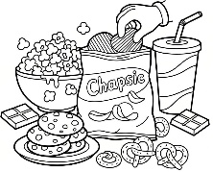  snacks  dinner | pilot  doctor | 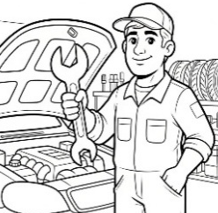  mechanic  teacher | 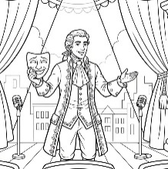  actor  manager | 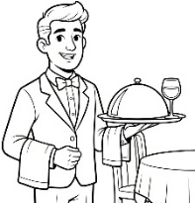  a  vet  waiter | 